Table 1 See Note 1 for Authors Work
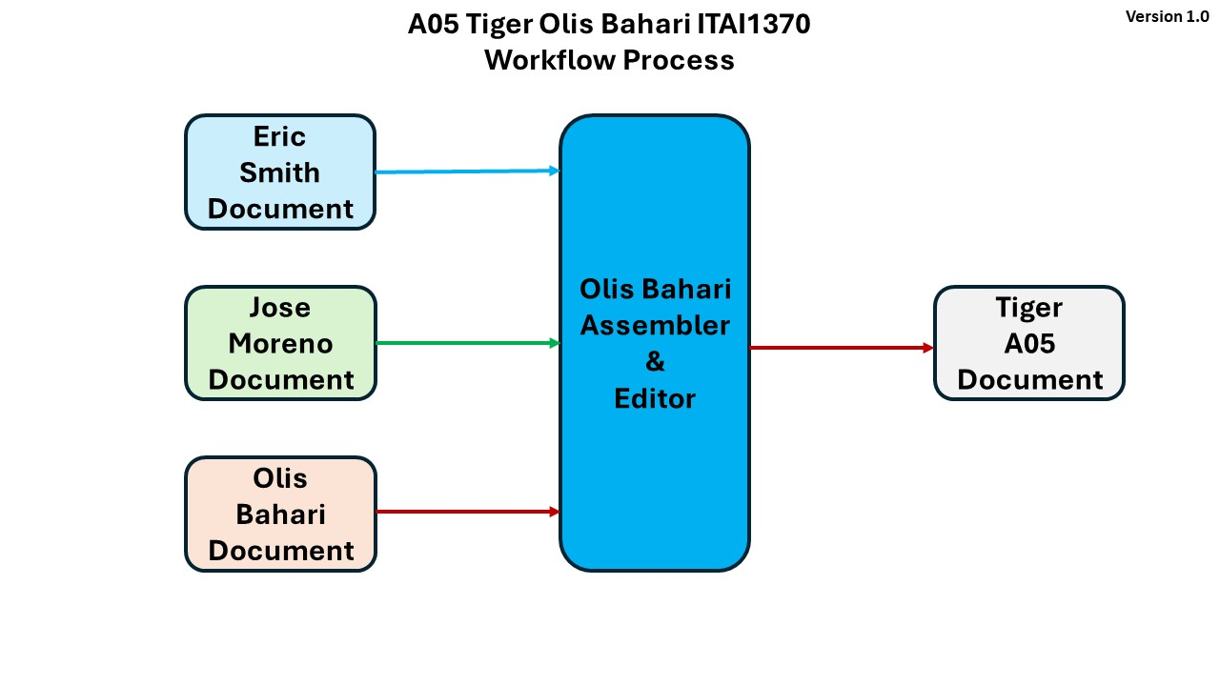

Introduction
Large language models (LLMs) powered by artificial intelligence (AI) continue to improve rapidly. In 2023, OpenAI introduced GPT-4, a next-generation language model that replaced the earlier version of ChatGPT. Compared with earlier versions of ChatGPT, GPT-4 was designed to provide stronger reasoning, greater creativity, improved reliability, and broader knowledge across a wide range of tasks and applications. This article explores GPT-4's advancements and key differences from earlier versions of ChatGPT.

Improvements Incorporated into GPT-4
OpenAI introduced several major improvements in GPT-4 compared with earlier language models. One of the most significant advancements is its ability to accept both text and image inputs while generating text outputs, making it a multimodal AI model. This capability allows it to analyze visual information and written language.
According to OpenAI, GPT-4 demonstrates stronger reasoning, greater creativity, and improved performance on complex tasks and requests. It is also better at following detailed instructions and producing accurate, reliable responses. OpenAI also reported human-level performance on several professional and academic benchmark examinations, including a top 10% score on a simulated bar examination. OpenAI emphasized improvements in safety and alignment, making GPT-4 more dependable and better aligned with user intentions than previous versions.

Improvements Incorporated into GPT-4
OpenAI identifies several significant improvements in GPT-4 over previous models. The most notable advancement is that GPT-4 is a multimodal model capable of accepting both text and image inputs while generating text outputs. Compared with earlier models, OpenAI also reports stronger reasoning abilities and improved performance on numerous professional and academic benchmark examinations, including law, mathematics, and science assessments. Another major improvement is enhanced factual accuracy and more consistent instruction following through post-training alignment techniques. OpenAI also emphasizes predictable scaling, allowing researchers to better forecast the model's performance during training. Although GPT-4 remains imperfect and can still generate inaccurate information, OpenAI reports substantial safety improvements and fewer responses that violate its usage policies.

GPT-4 Compared to ChatGPT
GPT-4 is a significant improvement over ChatGPT, which was powered by GPT-3.5. According to OpenAI, GPT-4 delivers more accurate responses, stronger reasoning abilities, and better performance on complex tasks. It follows detailed instructions more effectively, maintains context during longer conversations, and generates more organized, coherent, and creative responses. It also produces fewer factual errors than its predecessor and, with multimodal capability, can accept both text and image inputs, unlike the original version of ChatGPT.

GPT-4 Compared to ChatGPT
GPT-4 expands the capabilities of the original version of ChatGPT, which was initially powered by GPT-3.5. According to OpenAI, GPT-4 produces more reliable, accurate, and nuanced responses while handling more complex instructions and reasoning tasks. It also performs better across a wide variety of academic and professional evaluations and demonstrates stronger multilingual capabilities than earlier models. One of the most important differences is GPT-4's multimodal capability, enabling it to analyze images in addition to text, whereas the original version of ChatGPT accepted only text input. Despite these improvements, OpenAI notes that GPT-4 still has limitations, including occasional hallucinations and reasoning errors.

Comparing ChatGPT to GPT-4 Table
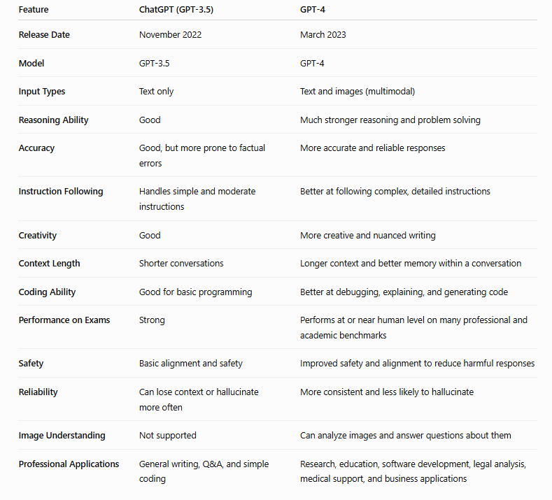

GPT-4: Improvements and Comparison with ChatGPT
The release of GPT-4 in March 2023 marked an important milestone in the development of large language models. Developed by OpenAI, GPT-4 was introduced as a more capable and reliable successor to earlier GPT models. According to OpenAI's research announcement and technical report, GPT-4 was designed to improve reasoning, accuracy, safety, and overall performance while expanding its ability to process different types of input. This paper summarizes the major improvements in GPT-4 and its differences from the original version of ChatGPT.

Conclusion
GPT-4 represents a major advancement in artificial intelligence. According to OpenAI, it offers stronger reasoning, greater factual accuracy, enhanced safety, and a better ability to follow complex instructions than earlier versions. Its multimodal capability allows it to process both text and image inputs. Compared with the original version of ChatGPT, GPT-4 is better equipped to support educational, professional, and real-world applications. Overall, these advancements make GPT-4 a more capable tool for tackling complex problems across many fields.

Conclusion
According to OpenAI, GPT-4 represents a substantial advancement in large language model technology. Its improvements in reasoning, instruction following, multimodal capabilities, benchmark performance, and safety make it more capable than the original version of ChatGPT. While OpenAI acknowledges that GPT-4 is not entirely reliable and still has limitations, the model demonstrates progress toward creating AI systems that are more useful, trustworthy, and effective across a broad range of real-world applications.

Extra: Comparing GPT-4 to GPT-5.6 Table
Compared with GPT-4, GPT-5.6 introduces several important advances:
- More advanced reasoning for solving complex, multi-step problems.
- Higher-quality coding, including debugging, software development, and repository analysis.
- Improved research capabilities, with better handling of large collections of documents.
- Greater efficiency, delivering more useful work with fewer tokens.
- Enhanced agentic workflows, allowing the model to complete longer, multi-step tasks.
- Stronger design judgment, enabling it to inspect and refine interfaces rather than only generating code.
- Multiple model options (Sol, Terra, Luna) that let users balance speed, capability, and cost.
- Improved safety systems for sensitive domains

References
OpenAI. (2023, March 14). GPT-4 Research. https://openai.com/index/gpt-4-research/
OpenAI. (2023, March 14). GPT-4 Technical Report. https://cdn.openai.com/papers/gpt-4.pdf

References
ChatGPT: Comparing ChatGPT to GPT-4 and GPT-4 to GPT 5.6 Tables

Note 1:
Blue color is used for Eric Smith work.
Green color is used for Jose Moreno work.
Brown color is used for Olis Bahari work.

